**Name:** alaa ahmed ibrahim

**B.N/**195

**Topic:** programming languages

**Application Brief:**

1-This project was chosen due to its advantages and importance in the development of science and technology as these languages ​​changed the course of life where work and innovation can be done through the computer device, so I thought about writing about these languages ​​specifically.

2-Programming languages ​​are one of the most complex and best languages ​​because they are the link between you and the computer where you can give him a set of orders by writing codes, not only this, but it can also be used as entertainment means such as making games and creating sites that contain movies and videos that entertains the person who sees it.

**Screenshots:**

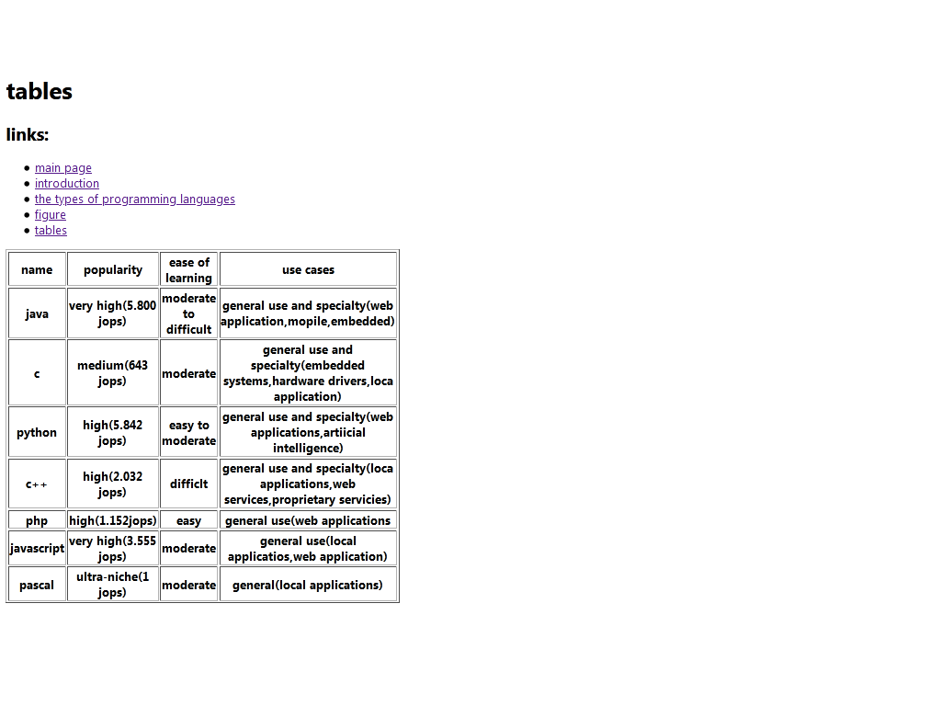

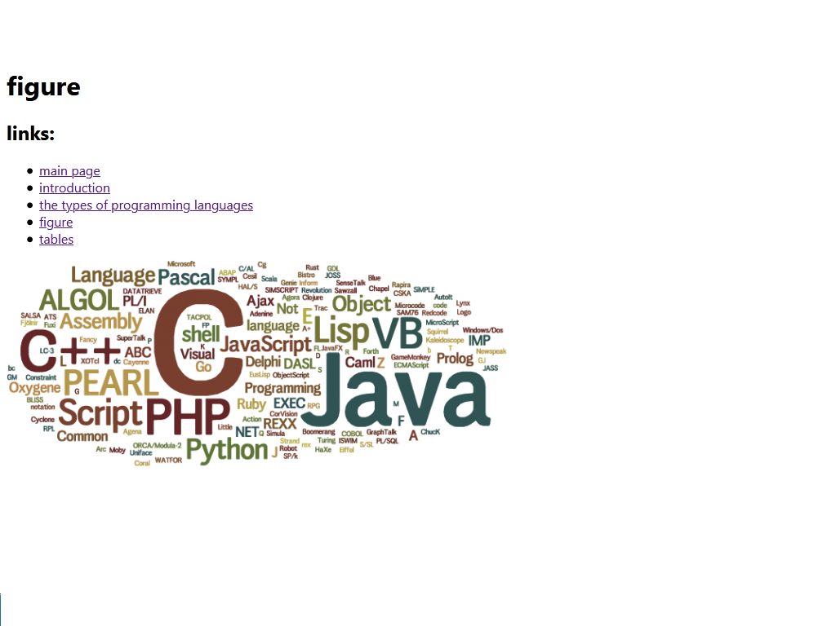

**source code:**

<html>

<head>

<title>programming languages</title>

</head>

<body>

<h1>figure</h1>

<h2>links:</h2>

<ul>

<li><a href="[main page.html](view-source:file:///G:/New%20folder/main%20page.html)"> main page </a></li>

<li><a href="[introduction.html](view-source:file:///G:/New%20folder/introduction.html)"> introduction </a></li>

<li><a href="[types of programming languages.html](view-source:file:///G:/New%20folder/types%20of%20programming%20languages.html)"> the types of programming languages </a></li>

<li><a href="[figure.html](view-source:file:///G:/New%20folder/figure.html)"> figure </a></li>

<li><a href="[tables.html](view-source:file:///G:/New%20folder/tables.html)"> tables </a></li>

</ul>

<img src="[different-programming-languages.png](view-source:file:///G:/New%20folder/different-programming-languages.png)"alt="different-programming-languages">

</body>

</html>